EXP-1:
INSTALLATION OF NMAP AND WIRESHARK:

Installing Nmap on Windows

Step 1: Download Nmap
Visit the official Nmap website.
Under the "Microsoft Windows binaries" section, click on the self-installer link (e.g., nmap-setup.exe).
Step 2: Run the Installer
Locate the downloaded file (e.g., nmap-setup.exe) and double-click it to start the installation.
Follow the installation wizard:
License Agreement: Accept the license agreement.
Choose Components: Select the default components (recommended) or customize as needed.
Installation Directory: Choose a location to install Nmap or use the default path (e.g., C:\Program Files (x86)\Nmap).
Add to PATH: Ensure the option to add Nmap to your system's PATH variable is selected (default).
Step 3: Complete Installation
Click Install and wait for the installation to complete.
Once installed, launch the Nmap Command-Line Interface (CLI) from the Start menu or open cmd and type nmap to verify installation.

Installing Wireshark on Windows

Step 1: Download Wireshark
Visit the official Wireshark website.
Click on the Windows Installer (64-bit) link to download the .exe file.
Step 2: Run the Installer
Locate the downloaded file (e.g., Wireshark-win64-x.x.x.exe) and double-click it to start the installation.
Follow the installation wizard:
License Agreement: Accept the license agreement.
Choose Components: Select the default components (recommended). Ensure the "WinPcap" or "Npcap" option is selected for packet capturing.
Select Additional Tasks: Enable desktop shortcuts or start menu entries if desired.
Step 3: Install Npcap
During the installation, the Npcap installer will launch (Npcap is required for live packet capture).
Follow the prompts in the Npcap setup:
Agree to the license agreement.
Select the default settings (recommended).
Step 4: Complete Installation
Once the Wireshark installation is complete, click Finish.
Open Wireshark from the Start menu to ensure it launches correctly.
3. Verifying the Installations
Verify Nmap
Open cmd or PowerShell.
Type the command:
bash
Copy
Edit
nmap --version
You should see the installed Nmap version and system details.
Verify Wireshark
Open Wireshark from the Start menu.
Ensure the application starts without errors and lists your network interfaces.
Test live packet capturing:
Select a network interface and click Start.
Monitor the network traffic to confirm it's working.

Aim : Network Discovery and Mapping
A. Utilize tools like Nmap and Wireshark to perform network discovery.
B. Create a visual map of the network infrastructure.
C. Analyze the implications of the network structure on management strategies

A)

program :

import subprocess
from scapy.all import sniff,ARP,conf
def run_nmap_scan(target_ip):
print(f"Running Nmap scan on {target_ip}..")
try:
result=subprocess.check_output(["nmap","-sP",target_ip],text=True)
print(result)
except FileNotFoundError:
print("nmap is not intsalled,")
except subprocess.CalledProcessError as e:
print(f"error running nmap :{e}")

def capture_packets(interface="eth0",timeout=10):
print(f"Capturing packets on interface {interface} for {timeout} seconds..")
def arp_display(packet):
if packet[ARP].op ==1:
return f"Request :{packet[ARP].psrc} is asking about {packet[ARP].pdst}"
elif packet[ARP].op ==2:
return f"Reply :{packet[ARP].hwsrc} has address {packet[ARP].hwdst}"

try:
packets=sniff(iface=interface ,filter="arp",timeout=timeout,prn=arp_display)
print("\nCaptured packets:")
for pkt in packets:
print(pkt.summary())
except PermissionError:
print("You need adminstrative privilage to capture packets .")
except Exception as e:
print(f"error capturing packets : {e}")
if __name__=="__main__":
print("network Discovery Tool")
print("1.run namp scan")
print("2.capturing network packet ")
choice =input("Enter your choice (1/2): ")
if choice=="1":
ip=input("enter ip :")
run_nmap_scan(ip)
elif choice=="2":
iface =input("enter the network nterface (e.g.,eth0,wlan0): ")
capture_packets(interface =iface)
else:
print("invalid choice")

output :

network Discovery Tool
1.run namp scan
Enter your choice (1/2): 1
enter ip :192.168.64.1
Running Nmap scan on 192.168.64.1..
Starting Nmap 7.95 ( https://nmap.org ) at 2025-01-17 14:26 India Standard Time
Nmap scan report for 192.168.64.1
Host is up.
Nmap done: 1 IP address (1 host up) scanned in 0.46 seconds
-------------------
network Discovery Tool
1.run namp scan
2.capturing network packet
Enter your choice (1/2): 2
enter the network nterface (e.g.,eth0,wlan0): Ethernet
Capturing packets on interface Ethernet for 10 seconds..
Request :172.30.10.1 is asking about 172.30.11.81
Request :172.30.10.1 is asking about 172.30.13.167
Request :172.30.10.1 is asking about 172.30.13.76

Captured packets:
Ether / ARP who has 172.30.11.81 says 172.30.10.1 / Padding
Ether / ARP who has 172.30.13.167 says 172.30.10.1 / Padding
Ether / ARP who has 172.30.13.76 says 172.30.10.1 / Padding

B)
program :

import networkx as nx
import matplotlib.pyplot as plt

def create_network_map():
# Create an empty graph
G = nx.Graph()

# Add nodes (representing devices)
G.add_node("Router")
G.add_node("Switch1")
G.add_node("Switch2")
G.add_node("PC1")
G.add_node("PC2")
G.add_node("PC3")

# Add edges (representing connections between devices)
G.add_edge("Router", "Switch1")
G.add_edge("Router", "Switch2")
G.add_edge("Switch1", "PC1")
G.add_edge("Switch1", "PC2")
G.add_edge("Switch2", "PC3")

# Set positions for nodes to make the graph look more like a network
pos = {
"Router": (0, 0),
"Switch1": (-1, -1),
"Switch2": (1, -1),
"PC1": (-2, -2),
"PC2": (-1, -2),
"PC3": (2, -2)
}

# Draw the network graph
plt.figure(figsize=(8, 6))
nx.draw(G, pos, with_labels=True, node_size=2000, node_color="lightblue", font_size=10, font_weight="bold", edge_color="gray")

# Display the network graph
plt.title("Network Infrastructure Map")
plt.show()

# Call the function to create and visualize the network map
create_network_map()

c)
program :

import networkx as nx
import matplotlib.pyplot as plt

def analyze_network_structure():
# Create a network graph (can represent a simple network infrastructure)
G = nx.Graph()

# Add nodes representing devices
G.add_node("Router")
G.add_node("Switch1")
G.add_node("Switch2")
G.add_node("PC1")
G.add_node("PC2")
G.add_node("PC3")

# Add edges representing connections between devices
G.add_edge("Router", "Switch1")
G.add_edge("Router", "Switch2")
G.add_edge("Switch1", "PC1")
G.add_edge("Switch1", "PC2")
G.add_edge("Switch2", "PC3")

# Calculate centrality measures
degree_centrality = nx.degree_centrality(G)
betweenness_centrality = nx.betweenness_centrality(G)
closeness_centrality = nx.closeness_centrality(G)

# Calculate clustering coefficients
clustering = nx.clustering(G)

# Network Density: A measure of the overall connectivity of the network
network_density = nx.density(G)

# Print out the calculated metrics
print("Degree Centrality:", degree_centrality)
print("Betweenness Centrality:", betweenness_centrality)
print("Closeness Centrality:", closeness_centrality)
print("Clustering Coefficients:", clustering)
print("Network Density:", network_density)

# Implications of these metrics on management strategies
print("\nImplications for Management Strategies:")
if network_density < 0.5:
print("- The network is sparsely connected. Consider improving connectivity between critical devices to avoid isolation in case of failure.")
else:
print("- The network is relatively well-connected. Focus on ensuring reliability of critical components like switches or routers.")

# Identifying critical nodes
critical_nodes = [node for node, centrality in betweenness_centrality.items() if centrality > 0.2]
if critical_nodes:
print("- Critical nodes such as", critical_nodes, "should be monitored more closely to ensure efficient operation.")

# Visualizing the network with centrality-based node size
plt.figure(figsize=(8, 6))
node_size = [v * 2000 for v in degree_centrality.values()] # Node size based on degree centrality
pos = nx.spring_layout(G) # Layout for visualization
nx.draw(G, pos, with_labels=True, node_size=node_size, node_color="lightblue", font_size=12, font_weight="bold", edge_color="gray")
plt.title("Network Structure with Centrality-based Node Size")
plt.show()

# Call the function to analyze the network structure
analyze_network_structure()

EXP-3
Automation with Ansible
A. Set up Ansible for network configuration management.
import os
import subprocess

def install_ansible():
"""Installs Ansible using pip."""
try:
subprocess.run(["pip", "install", "ansible"], check=True)
print("Ansible installed successfully.")
except subprocess.CalledProcessError:
print("Error installing Ansible.")

def setup_ansible_directories():
"""Creates necessary Ansible directories."""
ansible_dir = os.path.expanduser("~/.ansible")
inventory_file = os.path.expanduser("~/.ansible/inventory.ini")

if not os.path.exists(ansible_dir):
os.makedirs(ansible_dir)
print(f"Created Ansible directory at {ansible_dir}")

if not os.path.exists(inventory_file):
with open(inventory_file, "w") as f:
f.write("[network_devices]\n")
f.write("router ansible_host=192.168.1.1 ansible_user=admin ansible_password=yourpassword ansible_connection=network_cli ansible_network_os=ios\n")
print(f"Created inventory file at {inventory_file}")
else:
print("Inventory file already exists.")

def verify_ansible_installation():
"""Verifies if Ansible is installed properly."""
try:
subprocess.run(["ansible", "--version"], check=True)
print("Ansible is set up correctly.")
except FileNotFoundError:
print("Ansible is not installed correctly.")

def main():
install_ansible()
setup_ansible_directories()
verify_ansible_installation()

if __name__ == "__main__":
main()

B. Automate routine tasks such as software updates and configuration changes.
import os
import subprocess

def update_system():
"""Updates the package lists and upgrades installed packages."""
print("Updating system packages...")
subprocess.run(["sudo", "apt", "update"], check=True)
subprocess.run(["sudo", "apt", "upgrade", "-y"], check=True)
print("System update completed.")

def modify_config(file_path, old_text, new_text):
"""Modifies configuration files by replacing text."""
if os.path.exists(file_path):
with open(file_path, 'r') as file:
content = file.read()

content = content.replace(old_text, new_text)

with open(file_path, 'w') as file:
file.write(content)
print(f"Updated configuration in {file_path}.")
else:
print(f"Configuration file {file_path} not found.")

def restart_service(service_name):
"""Restarts a system service."""
print(f"Restarting {service_name} service...")
subprocess.run(["sudo", "systemctl", "restart", service_name], check=True)
print(f"{service_name} service restarted.")

def main():
try:
update_system()
modify_config("/etc/example.conf", "old_value", "new_value")
restart_service("apache2")
print("Automation tasks completed successfully.")
except subprocess.CalledProcessError as e:
print(f"Error executing command: {e}")
except Exception as e:
print(f"Unexpected error: {e}")

if __name__ == "__main__":
main()

C. Evaluate the impact of automation on efficiency and responsiveness.
import time
import random

def manual_process():
"""Simulates a manual task with variable execution time."""
time.sleep(random.uniform(1, 3)) # Simulating manual delays
return random.randint(80, 100) # Efficiency score out of 100

def automated_process():
"""Simulates an automated task with consistent execution time."""
time.sleep(random.uniform(0.2, 0.5)) # Faster execution
return random.randint(90, 100) # Higher efficiency score

def evaluate_impact(trials=10):
manual_times = []
manual_efficiencies = []
automated_times = []
automated_efficiencies = []

for _ in range(trials):
# Measuring manual process
start = time.time()
manual_efficiency = manual_process()
end = time.time()
manual_times.append(end - start)
manual_efficiencies.append(manual_efficiency)

# Measuring automated process
start = time.time()
automated_efficiency = automated_process()
end = time.time()
automated_times.append(end - start)
automated_efficiencies.append(automated_efficiency)

# Computing averages
avg_manual_time = sum(manual_times) / trials
avg_manual_efficiency = sum(manual_efficiencies) / trials
avg_automated_time = sum(automated_times) / trials
avg_automated_efficiency = sum(automated_efficiencies) / trials

# Displaying results
print("Impact of Automation on Efficiency and Responsiveness:")
print(f"Average Manual Time: {avg_manual_time:.2f} seconds")
print(f"Average Manual Efficiency: {avg_manual_efficiency:.2f}")
print(f"Average Automated Time: {avg_automated_time:.2f} seconds")
print(f"Average Automated Efficiency: {avg_automated_efficiency:.2f}")
print(f"Efficiency Improvement: {avg_automated_efficiency - avg_manual_efficiency:.2f}%")
print(f"Time Reduction: {((avg_manual_time - avg_automated_time) / avg_manual_time) * 100:.2f}%")

if __name__ == "__main__":
evaluate_impact()

EXP-4
Fault Detection with Wireshark and Nagios

This script:
Captures packets using pyshark.
Identifies potential faults (high latency, dropped packets)
Queries Nagios to check service/host status.
Prerequisites
- Wireshark (tshark) Installation
  - Install tshark (command-line version of Wireshark)
  - For Ubuntu/Debian: sudo apt install tshark
  - For Windows: Install Wireshark and add tshark to the system PATH
- Nagios Setup
  - Install Nagios on the monitoring server
  - Configure Nagios for network health monitoring
  - Create a custom Nagios plugin to handle fault alerts.
import pyshark
import requests
import json
import time

# Nagios API Configuration (Change for your setup)
NAGIOS_URL = "http://your-nagios-server/cgi-bin/status-json.cgi" # Adjust for your Nagios setup
NAGIOS_USER = "your_username"
NAGIOS_PASS = "your_password"

# Network Capture Configuration
INTERFACE = "eth0" # Change to your network interface
PACKET_LIMIT = 50 # Number of packets to analyze
LATENCY_THRESHOLD = 100 # Latency threshold in ms

def capture_packets(interface, limit):
"""Captures network packets and detects anomalies."""
print("[*] Capturing packets using Wireshark...")
cap = pyshark.LiveCapture(interface=interface)

count = 0
for packet in cap.sniff_continuously(packet_count=limit):
count += 1
try:
if 'IP' in packet:
src = packet.ip.src
dst = packet.ip.dst
protocol = packet.transport_layer
length = packet.length
timestamp = float(packet.sniff_timestamp)

# Latency check (example using TCP)
if hasattr(packet, 'tcp') and hasattr(packet.tcp, 'time_delta'):
latency = float(packet.tcp.time_delta) * 1000 # Convert to ms
if latency > LATENCY_THRESHOLD:
print(f"[!] High latency detected: {latency}ms from {src} to {dst}")

print(f"Packet {count}: {protocol} {src} -> {dst}, Length: {length}")
except AttributeError:
continue

def check_nagios_status():
"""Fetches host and service status from Nagios."""
try:
response = requests.get(NAGIOS_URL, auth=(NAGIOS_USER, NAGIOS_PASS))
if response.status_code == 200:
data = json.loads(response.text)
print("[*] Nagios Status Fetched Successfully")

for host in data.get("hosts", []):
hostname = host.get("name")
status = host.get("status")
print(f"Host: {hostname}, Status: {status}")

for service in data.get("services", []):
service_name = service.get("name")
service_status = service.get("status")
print(f"Service: {service_name}, Status: {service_status}")

else:
print("[!] Error fetching Nagios data")

except requests.RequestException as e:
print(f"[!] Nagios request failed: {e}")

if __name__ == "__main__":
print("[*] Starting Fault Detection System")

# Step 1: Capture Packets
capture_packets(INTERFACE, PACKET_LIMIT)

# Step 2: Check Nagios for Faults
check_nagios_status()

print("[*] Fault Detection Completed")

EX-5
Network Management and System Operation Lab Manual
Protocol Analysis with tcpdump
Objective
To analyze network traffic using tcpdump, capture packets, and understand network communication protocols.
Introduction
tcpdump is a command-line packet analyzer that captures network packets and displays their details. It helps in network troubleshooting, security analysis, and protocol learning.
Prerequisites
- A Linux system with tcpdump installed.
- Root or sudo privileges.
- Basic knowledge of networking concepts.
Basic tcpdump Commands
- Capture packets on a specific interface:
- sudo tcpdump -i eth0
  - Captures live traffic on the eth0 network interface.
- Capture packets and save to a file:
- sudo tcpdump -i eth0 -w capture.pcap
  - Saves packets for later analysis using Wireshark or tcpdump -r.
- Read and analyze a capture file:
- sudo tcpdump -r capture.pcap
  - Reads previously captured packets.
- Filter packets by host:
- sudo tcpdump -i eth0 host (your_ip_address)
  - Captures only traffic from/to the given IP address.
- Filter packets by port (e.g., HTTP traffic):
- sudo tcpdump -i eth0 port 80
  - Captures only HTTP traffic.
- Filter packets by protocol (e.g., ICMP - ping):
- sudo tcpdump -i eth0 icmp
  - Captures ICMP packets used for ping requests.
- Display packet details with timestamps:
- sudo tcpdump -i eth0 -tttt
  - Shows precise timestamped packet logs.
Experiment: Capturing and Analyzing Network Traffic
Step 1: Capture Live Traffic
- Open a terminal.
- Run:
- sudo tcpdump -i eth0 -c 10
  - Captures 10 packets and stops.
Step 2: Analyze Specific Traffic
- Open a new terminal and start a ping:
- ping 8.8.8.8 -c 5
- Run tcpdump to capture ICMP packets:
- sudo tcpdump -i eth0 icmp
- Observe the packet exchange.
Step 3: Save and Read Packets
- Save packets to a file:
- sudo tcpdump -i eth0 -w test_capture.pcap
- Stop the capture (Ctrl + C).
- Read the file:
- sudo tcpdump -r test_capture.pcap

Exp - 07
Aim
To measure and analyze network traffic using ntopng.

Step-by-Step Procedure

Step 1: Install ntopng
🔹 On Ubuntu/Debian:
bash
CopyEdit
sudo apt update
sudo apt install software-properties-common
sudo add-apt-repository universe
sudo apt install ntopng
🔹 On CentOS/RHEL:
bash
CopyEdit
sudo yum install epel-release
sudo yum install ntopng
🔹 On Windows:
- Download installer from: https://www.ntop.org/products/traffic-analysis/ntop/
- Run the installer and follow instructions

Step 2: Configure ntopng
- Edit the config file (Linux):
bash
CopyEdit
sudo nano /etc/ntopng/ntopng.conf
Example config (for eth0):
ini
CopyEdit
-G=/var/run/ntopng.pid
-i=eth0
-w=3000
-i=eth0: Network interface
-w=3000: Web interface will run at port 3000
Save and exit the file.

Step 3: Start ntopng
bash
CopyEdit
sudo systemctl start ntopng
To start on boot:
bash
CopyEdit
sudo systemctl enable ntopng

Step 4: Access ntopng Web Interface
- Open your browser and go to:
arduino
CopyEdit
http://localhost:3000
or
cpp
CopyEdit
http://<your-ip-address>:3000
- Default login:
  - Username: admin
  - Password: admin (you will be asked to change it)

Step 5: Monitor Traffic in Real-Time
From the dashboard, explore:
- Dashboard – overall network usage summary
- Traffic – top talkers, apps, protocols
- Hosts – individual IPs using bandwidth
- Flows – real-time connections
- Interfaces – usage per interface

Step 6: Analyze Bandwidth Usage
- Check Top Talkers to identify who uses the most bandwidth.
- Use Protocols to see traffic breakdown (HTTP, HTTPS, DNS, etc.).
- Set filters for specific IPs or ports.
- Export reports or snapshots from the web interface.
Step 7: Stop or Restart ntopng (if needed)
bash
CopyEdit
sudo systemctl stop ntopng
sudo systemctl restart ntopng

output :
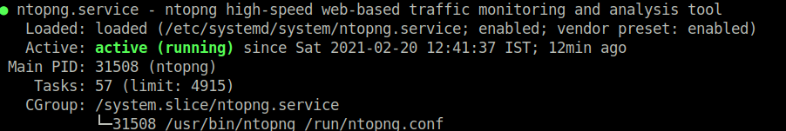

EX:6

AIM: TO Traffic Analysis with Wireshark and Bandwidth

DESCRIPTION: gain
Monitoring network traffic using Wireshark is an excellent way to
hands-on experience in capturing and analyzing network packets. Below is a step- by-step guide to performing a basic network traffic monitoring lab experiment using Wireshark:

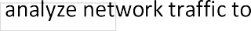
characteristics.
Prerequisites:
- A computer with Wireshark installed. Wireshark is available for various operating systems.
- Access to a network with active communication (e.g., internet access, local network, or virtual lab environment).

Steps:

- If you haven't already, download and install Wireshark on your computer.
Install Wireshark:

 | You can find the i | taller for your operating system on the Wireshark website.
- Start Wireshark: Launch Wireshark on your computer. Note that you might need administrative privileges to capture packets on some operating systems.
- Select the Network Interface: Wireshark allows you to choose the network interface for capturing packets. Select the appropriate interface connected to the network you want to monitor. For example, if you are connected via Wi-Fi, select the Wi-Fi interface.
Start Capturing Packets:
- Click on the "Start" button in Wireshark to begin capturing packets on the selected network interface.
Generate Network Traffic:
- To capture network traffic, you need to generate network activity. Perform various network activities such as browsing websites, sending emails, pinging other devices, or accessing network resources.
Stop Capturing Packets:
- After performing network activities, stop the packet capture in Wireshark by clicking the "Stop" button.
Analyze Captured Packets:
- Once the capture is stopped, you will see a list of captured packets in Wireshark's main window. Each row represents a captured packet, and the columns provide information about the source and destination addresses, protocols, and other packet details.
Apply Filters (Optional):
- To focus on specific packets of interest, you can use display filters in Wireshark. Filters allow you to show only packets matching specific criteria, such as source or destination IP, protocol, or port.

- Select a packet of interest from the list, and Wireshark will display detailed information about the packet, including the packet header, payload data, and other relevant details.
Inspect Packet Contents:
- Analyze Packet Timing and Flow: Use Wireshark's analysis features to examine packet timing, flow, and potential network issues or anomalies.
- Save Capture File (Optional): If you want to save the captured packets for further analysis or documentation, you can save the capture file in a format such as PCAP (Packet Capture).
- Review and Interpret Results: Review the captured packets, analyze network behavior, and interpret the results to gain insights into network traffic patterns and characteristics.

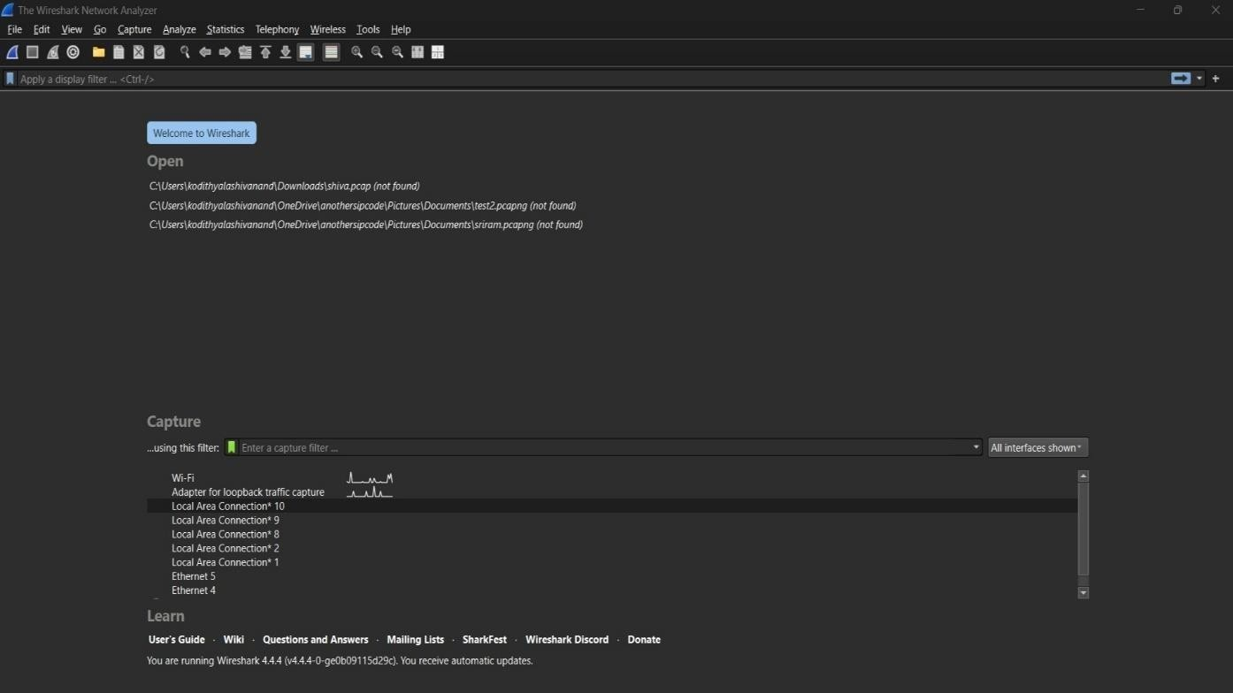

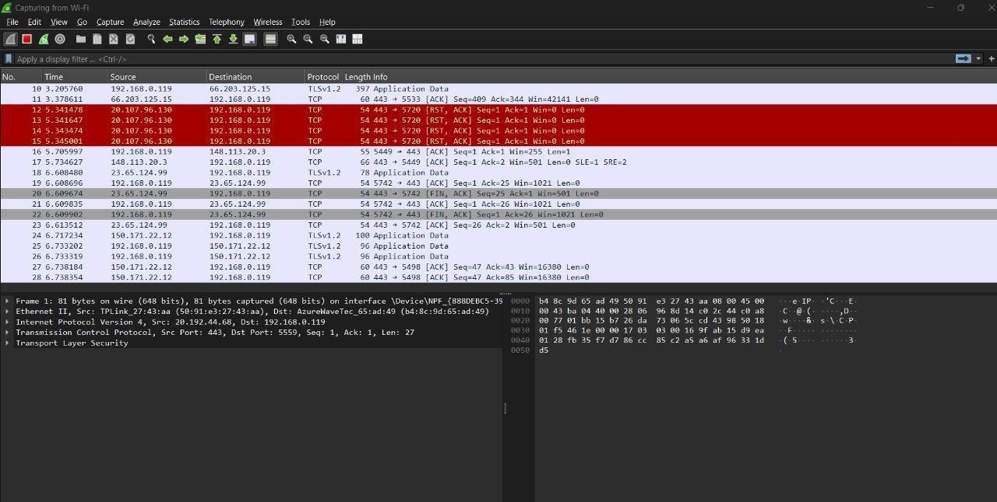

EXP-08:
Aim
To measure and analyze network traffic using ntopng.

Step-by-Step Procedure

✅ Step 1: Install ntopng
🔹 On Ubuntu/Debian:
bash
CopyEdit
sudo apt update
sudo apt install software-properties-common
sudo add-apt-repository universe
sudo apt install ntopng
🔹 On CentOS/RHEL:
bash
CopyEdit
sudo yum install epel-release
sudo yum install ntopng
🔹 On Windows:
- Download installer from: https://www.ntop.org/products/traffic-analysis/ntop/
- Run the installer and follow instructions

✅ Step 2: Configure ntopng
- Edit the config file (Linux):
bash
CopyEdit
sudo nano /etc/ntopng/ntopng.conf
Example config (for eth0):
ini
CopyEdit
-G=/var/run/ntopng.pid
-i=eth0
-w=3000
-i=eth0: Network interface
-w=3000: Web interface will run at port 3000
Save and exit the file.

✅ Step 3: Start ntopng
bash
CopyEdit
sudo systemctl start ntopng
To start on boot:
bash
CopyEdit
sudo systemctl enable ntopng

✅ Step 4: Access ntopng Web Interface
- Open your browser and go to:
arduino
CopyEdit
http://localhost:3000
or
cpp
CopyEdit
http://<your-ip-address>:3000
- Default login:
  - Username: admin
  - Password: admin (you will be asked to change it)

✅ Step 5: Monitor Traffic in Real-Time
From the dashboard, explore:
- Dashboard – overall network usage summary
- Traffic – top talkers, apps, protocols
- Hosts – individual IPs using bandwidth
- Flows – real-time connections
- Interfaces – usage per interface

✅ Step 6: Analyze Bandwidth Usage
- Check Top Talkers to identify who uses the most bandwidth.
- Use Protocols to see traffic breakdown (HTTP, HTTPS, DNS, etc.).
- Set filters for specific IPs or ports.
- Export reports or snapshots from the web interface.

✅ Step 7: Stop or Restart ntopng (if needed)
bash
CopyEdit
sudo systemctl stop ntopng
sudo systemctl restart ntopng

output :


EXP-10:
Aim : To configure a firewall with pfSense:
Procedure :
Step 1: Set Up pfSense
- Download pfSense: Visit pfSense Download and download the installation ISO.
- Create Bootable Media: Use a USB drive or CD/DVD with tools like Rufus (Windows) or dd (Linux/macOS).
- Install pfSense: Boot from the installation media and follow prompts to partition the disk and set up pfSense.
- Access Web Interface: Open a browser and go to 192.168.1.1. Default login: admin/pfsense.
Step 2: Basic Configuration
- Initial Setup Wizard: Set hostname, domain, DNS servers, and configure WAN (internet) and LAN (internal network).
- Set LAN IP: Assign an IP address for LAN (e.g., 192.168.1.1).
- Change Admin Password: Modify the default admin password for security.
Step 3: Firewall Configuration
- Configure LAN Rules: Go to Firewall > Rules. Add rules to allow traffic from LAN to WAN.
- Configure WAN Rules: Block all incoming WAN traffic by default, and create rules to allow specific services.
- Default Behavior: Ensure WAN-to-LAN traffic is blocked unless specifically allowed.
Step 4: NAT Configuration
- Port Forwarding: Go to Firewall > NAT. Add rules to forward ports for external access to LAN services (e.g., web servers).
Step 5: DHCP Server Configuration
- Enable DHCP: Go to Services > DHCP Server to assign IP addresses on the LAN.
- Static DHCP Leases: Optionally, assign fixed IPs to devices based on MAC addresses.
Step 6: Test and Verify
- Test LAN Connectivity: Verify LAN-to-WAN connectivity by accessing the internet.
- Test WAN Block: Ensure pfSense blocks external attempts to access internal devices.
- Use Diagnostic Tools: Utilize Ping, Traceroute, and Packet Capture for troubleshooting.
Step 7: Advanced Configuration (Optional)
- VPN Setup: Set up OpenVPN or IPsec for secure remote access.
- Intrusion Detection: Enable Snort or Suricata for traffic monitoring and protection.
- Traffic Shaping: Prioritize specific traffic (e.g., VoIP) under Firewall > Traffic Shaper.
- Logging: Monitor traffic and firewall events under Status > System Logs.
Step 8: Backup and Restore
- Backup: Go to Diagnostics > Backup/Restore to save configuration settings.
- Restore: Upload the backup file to restore settings if needed.

OUTPUT :

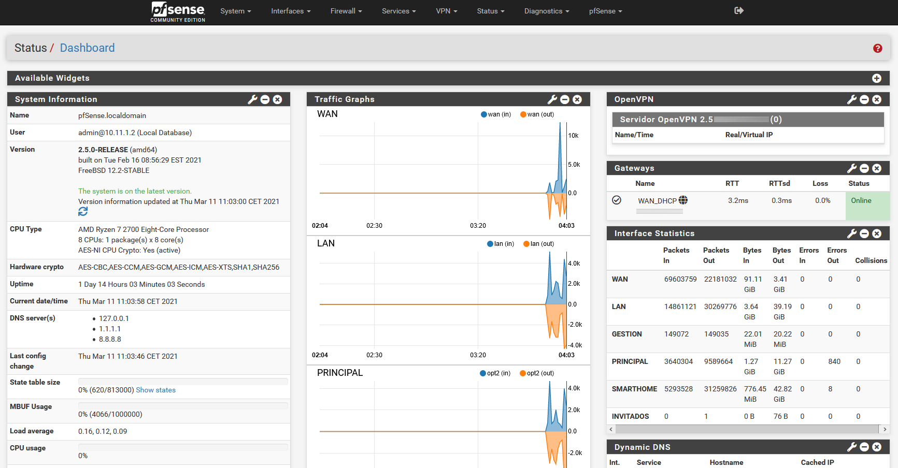

Exp - 11

AIM: To perform network discovery with nmap

DESCRIPTION: network
Nmap (Network Mapper) is a powerful open-source tool used for
exploration and security auditing. It can be used to discover hosts (devices) and services running on a network. Here's a guide on how to perform host and services discovery using Nmap:

Open your Kali linux Terminal and start the nmap scanning by typing nmap -sn <target_ip>
For example:
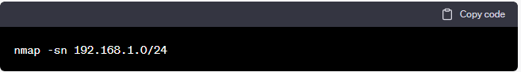
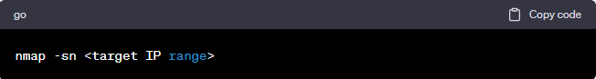

The -sn option tells Nmap to perform a ping scan to discover live hosts in the specified IP range.

If you want to perform a more aggressive host discovery,
4. Aggressive Host Discovery:
you can use the -Pn option, which skips the host discovery phase and sends probes directly to all specified targets:

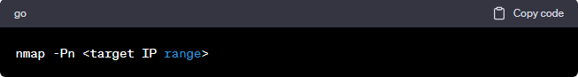

1.
To discover open ports and services running on the discovered
Service Discovery:
hosts, use the following command:
Save Output to a File:
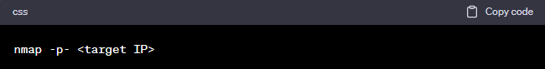

Replace | <target IP> | with the IP address of a live host identified in the previous step. The -p-
option tells Nmap to scan all 65,535 ports on the target.
6. Common Ports Discovery: |  |  | If you want to scan only common ports (top 1000), use the
following command:
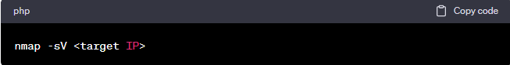
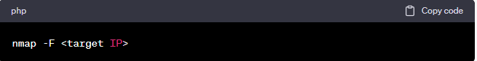
8. You can save the Nmap scan results to a file for later

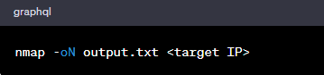
analysis using the -oN option:
Timing and Performance Options:

9. Nmap allows you to control the timing
and performance of the scan. By default, Nmap uses the option, which is a
-T4

balanced setting. You can adjust the timing to be more aggressive (e.g., -T5) or more conservative (e.g., -T3).

Exp - 9:

AIM: To perfom Risk assessment with OpenVAS

OpenVAS is available in different distributions and can be installed on Linux systems. You can find installation instructions on the OpenVAS website or within your Linux distribution's package manager.
1. Install OpenVAS:

Once OpenVAS is installed, you need to configure it before using it for scanning. The main configuration involves setting up administrative credentials and creating a user account.
2. Configure OpenVAS:

OpenVAS provides a web-based interface to manage and perform scans. Open your web browser and enter the URL of the OpenVAS web interface (usually https://localhost:9392).
3. Access OpenVAS Web Interface:

Use the administrator credentials or the user account you created during the configuration to log in to the OpenVAS web interface.
4. Log in to OpenVAS:

Before starting a scan, you need to define the target. A target can be an individual host, a range of IP addresses, or an entire network. Click on "Configuration" and then "Targets" to create a new target.
5. Create a Target:

Once the target is defined, you can create a scan task. Click on "Scans" and then "Task Wizard" to start the process. You'll need to provide the target and choose the scan type (e.g., Full and Fast, Full and Fast Ultimate, etc.).
6. Configure the Scan:

You can schedule the scan to run at a specific time or set it to run immediately. You can also configure the frequency of recurring scans if needed.
7. Schedule the Scan (Optional):

After configuring the scan, click on "Start" to initiate the scanning process.
8. Run the Scan:

Once the scan is completed, you can view the results by clicking on "Scans" and then selecting the completed scan task. The results will provide detailed information about the vulnerabilities discovered on the target system.
9. View Scan Results:

10. Analyze and Remediate Vulnerabilities: |  |  | Review the scan results to understand the
identified vulnerabilities. OpenVAS provides information about the severity of each vulnerability and potential remediation steps. Prioritize and address the high-risk vulnerabilities first.
11. Generate Reports: | OpenVAS allows you to generate reports summarizing the scan results.
Click on "Reports" and select the scan report you want to generate. The report can be saved in various formats, such as PDF or HTML.
12. Review and Rescan: |  | After addressing the vulnerabilities, you may want to perform another
scan to ensure that the fixes were successful and to identify any new issues that may have emerged.

